Colt Work

NABC

Input: provided from colt (log file data)

Output: math computation

Work on Notes

We’ll do orange & red stuff!

input: data

output: bandwidth

* Optimization problem!

[IT Explained: Bandwidth](https://www.paessler.com/support/it-knowledge/it-explained/bandwidth)

Bandwidth: Bandwidth is measured as the amount of data that can be transferred from one point to another within a network in a specific amount of time. Typically, bandwidth is expressed as a bitrate and measured in bits per second (bps).

* The term bandwidth refers to the transmission capacity of a connection and is an important factor when determining the quality and speed of a network or the internet connection.

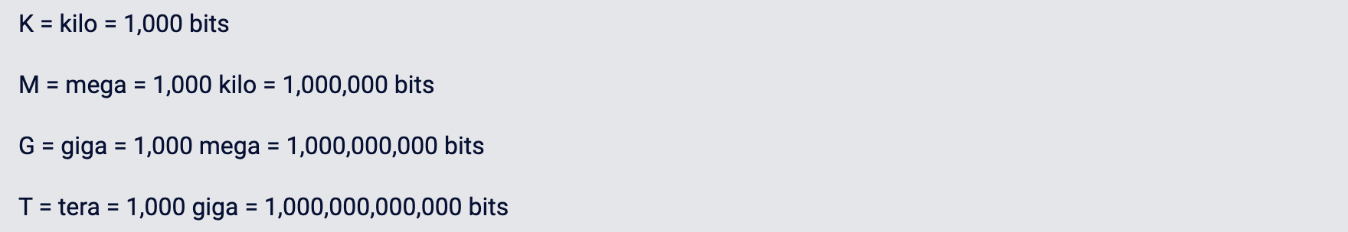

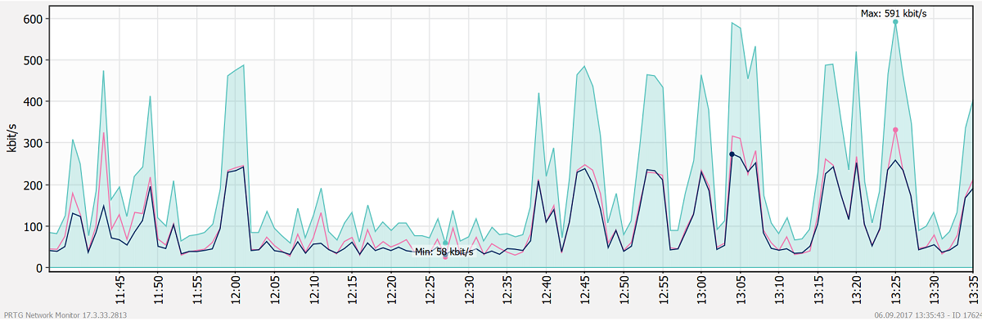

<https://www.solarwinds.com/>

<https://www.dnsstuff.com/improve-network-bandwidth>

[Network Bandwidth Analyzer Pack](https://www.solarwinds.com/network-bandwidth-analyzer-pack?CMP=ORG-BLG-DNS-X_WW_X_NP_X_X_EN_X_X-BAP-20191121_ImproveNetworkB_X_X_VidNo_X-X)

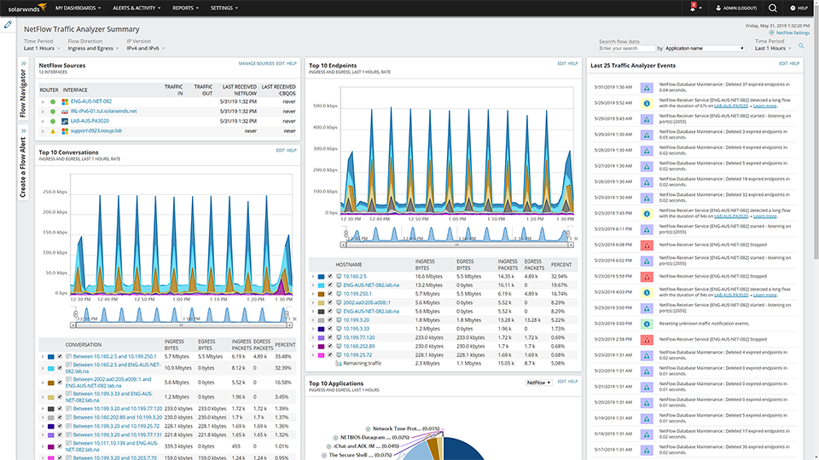

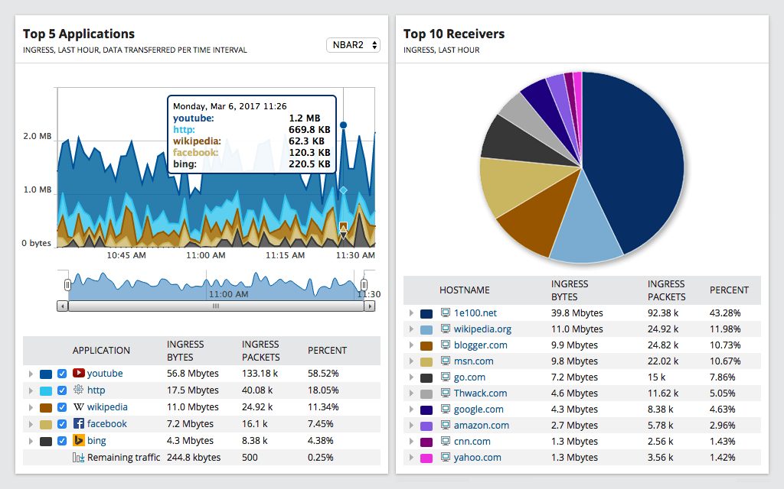

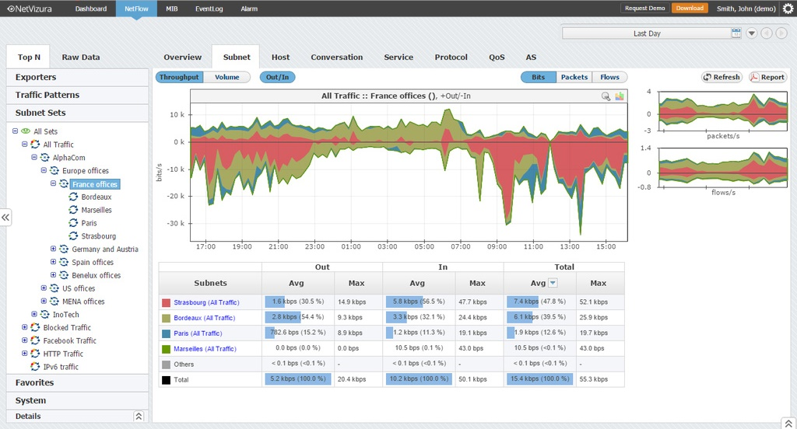

Bandwidth Analyzer:

* NetFlow Sources
* Top 5 NetFlow Sources by % Utilization
* Top 10 Endpoints
* Top 10 Applications
* Last 25 Traffic Analyzers Events
* IP Address Manager

Toolset:

* Trace route
* Interface monitor
* CPU monitor
* Memory monitor
* Response time monitor

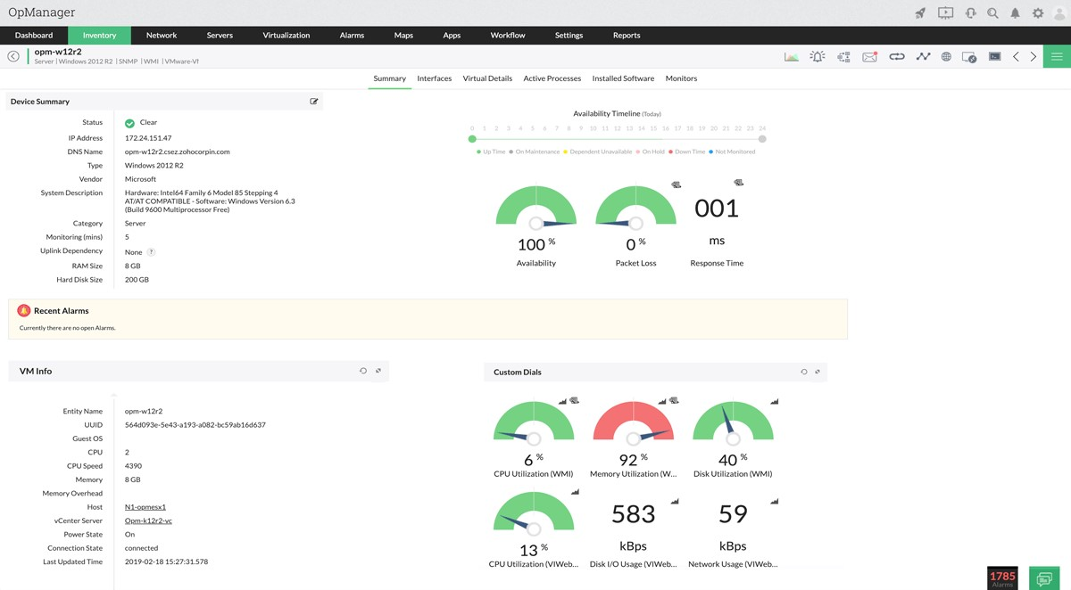

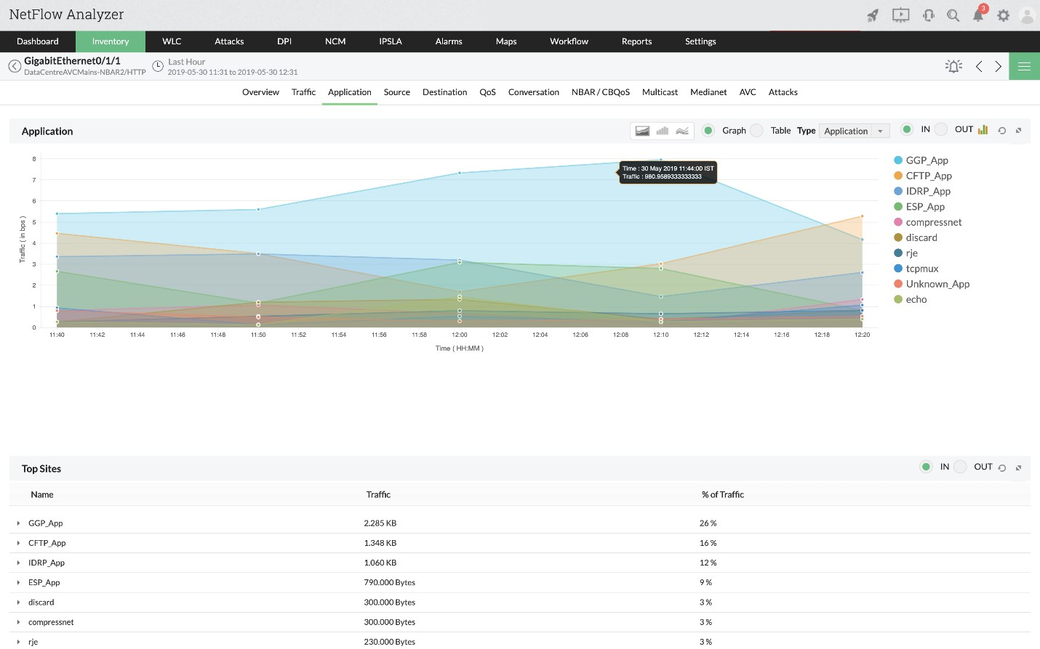

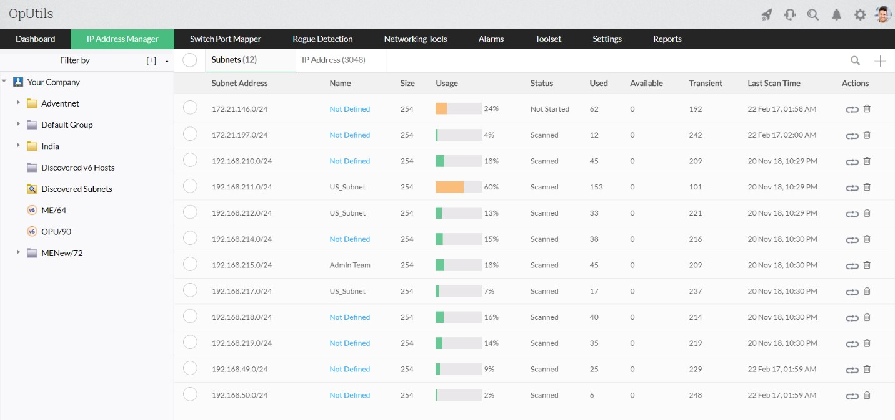

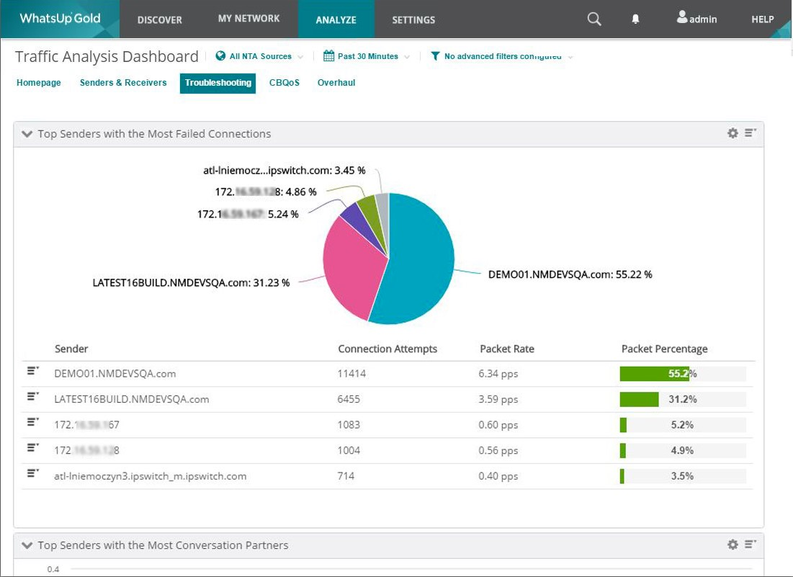

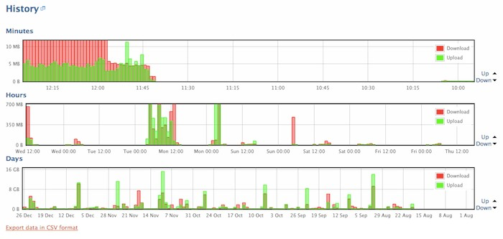

UI:

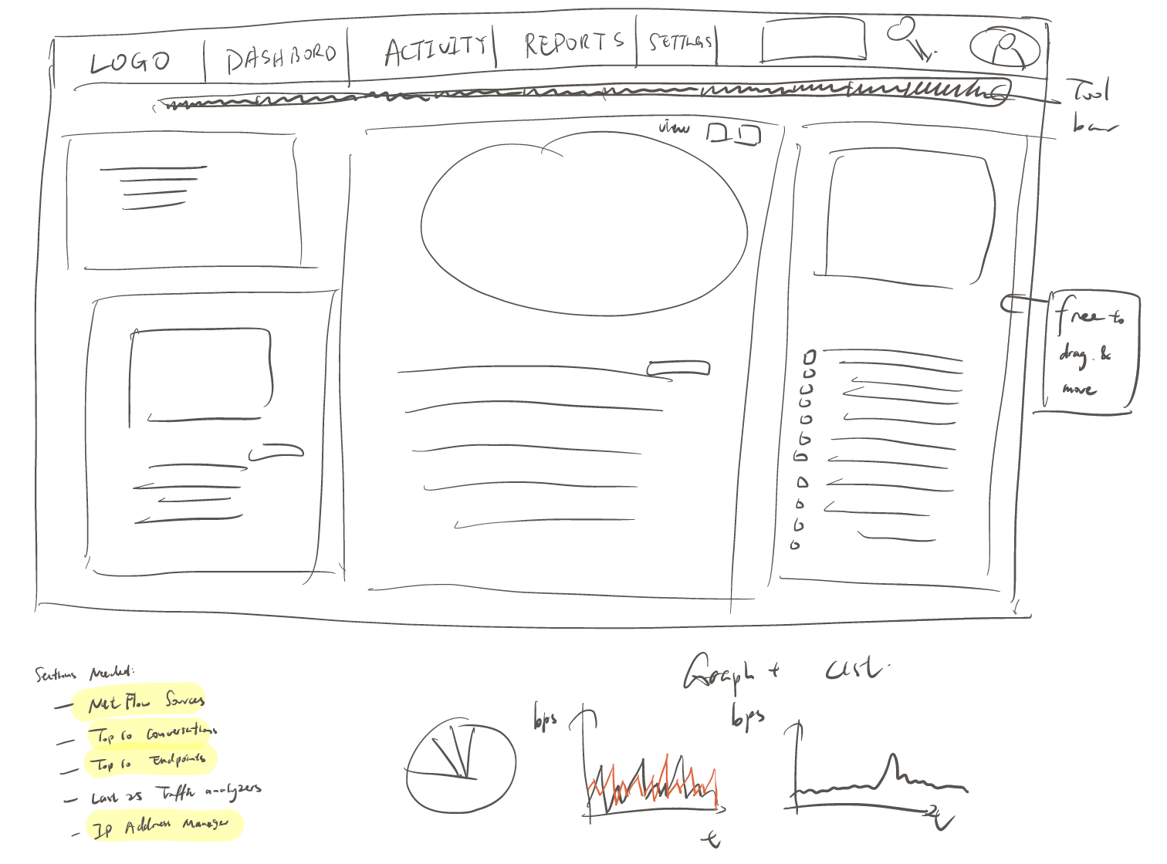

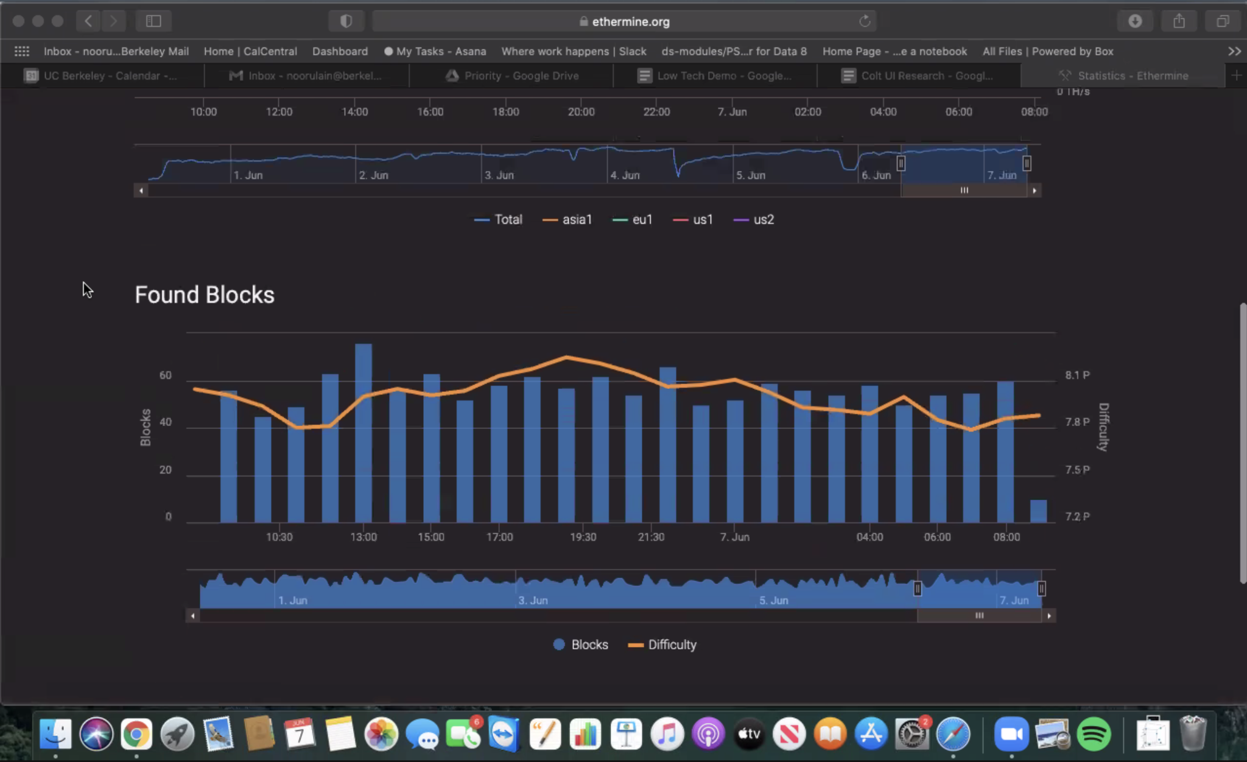

<https://streamlit.io/>

<https://ethermine.org/statistics> ← really nice plots!

User happiness - pie chart

Packet loss & bandwidth - x, y axis

Std & variance - bell curve

